Theory of computation (Mid)

Name: Saroar Hossan Suzan

ID: 2020117

Department of CSE

#. L(N) = {w|w contains abba}

Ans: 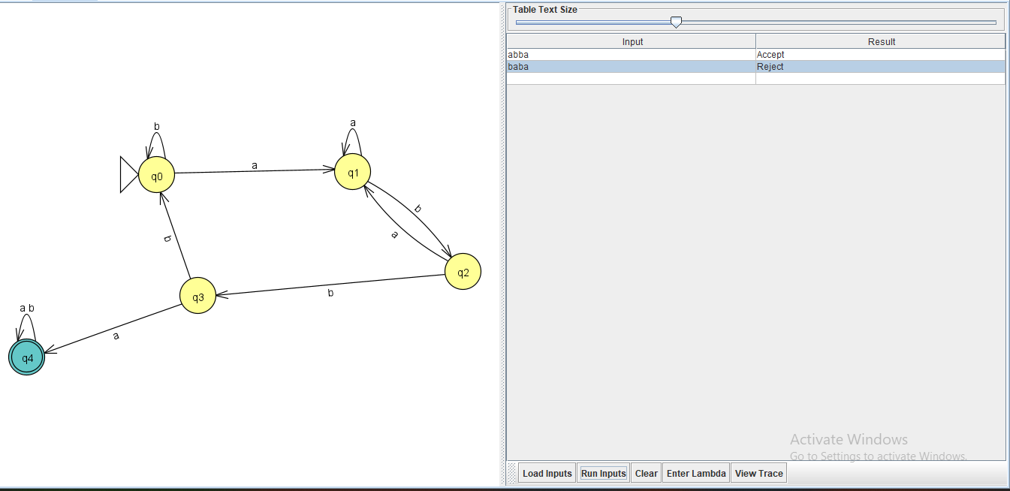

#.L(N) = {w|w doesn’t contain ab}

Ans: 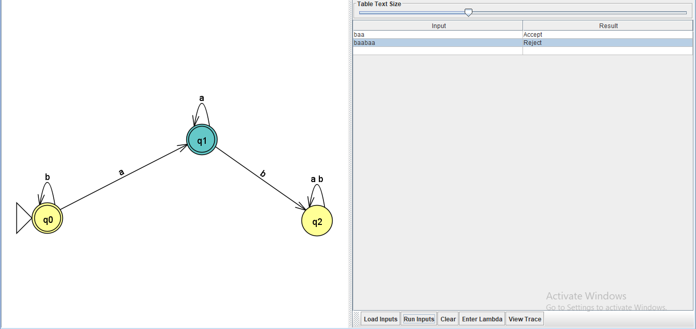

Theory of Computation (Quiz)

Ans: 